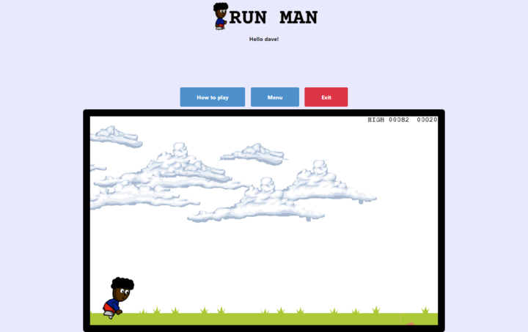

**🎮️ Name of the game: Run Man**  
**👥 Stakeholders:**

* Dev: [@davidyao3](https://twitter.com/DavidYao3)
* Design: from [OpenGameArt.org](https://opengameart.org/)
* QA: Microverse Team Support Engineering

# Overview

## 📐 Project scope

* **Budget: N/A**
* **Timeline: 5 working days**

## 🗣️ Elevator Pitch

*The goal of the game is to make the player jump over obstacles as long as possible. The longer you run, the more points you get*

## 💵 Monetization

*N/A*

# Story

*The goal of the game is to make the player jump over obstacles as long as possible. The longer you run, the more points you get*

# Gameplay

- If you didn't create a player yet, you will be invited to do so



- When the first page is loading you will see two buttons. One for starting the game and one for seeing the leaderboard scores.

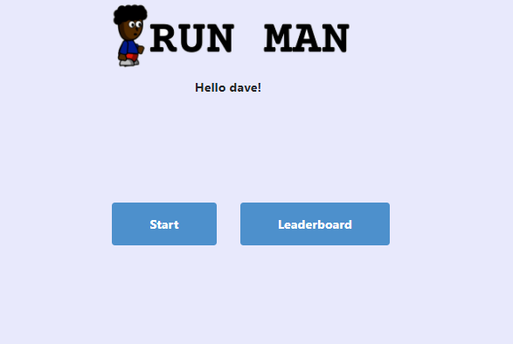

- If you click on the leaderboard button, you will see all the players scores

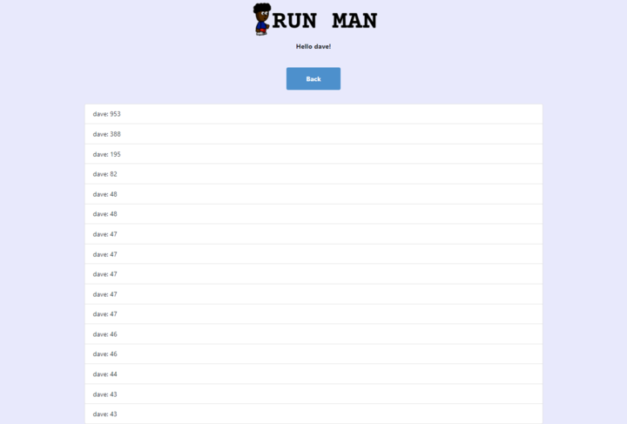

- If you click on the start button, you will see this menu

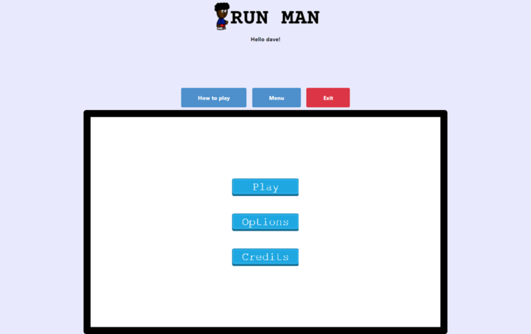

- If you click on the leaderboard button, you will see all the players scores

* **How to play**: click this button to see instructions for the game
* **Menu**: This button allows you to come back to the first screen of the game (where you have the play, options, and credits buttons)
* **Exit**: to exit and go back to the page where you have the start and the leaderboard buttons
* **Play**: to play the game
* **Options**: for the settings
* **Credits**: to see the credits

- If you click on the play button you will see the game scene. To start playing, click on `SPACE`

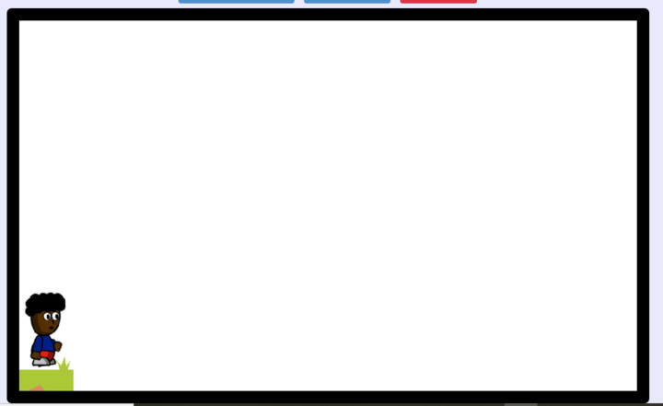

## Core Game Mechanic #1

* Details:
* How it works:

## Live demo

* Visit this link: [Run Man](https://nostalgic-perlman-e0971f.netlify.app/)

## Core Game Mechanic #3

* Details:
* How it works:

# Game elements

*Let's describe your game world, including all the characters, location, object, and other elements in it.*

## 👤 Characters

* Run Man



## 🗺️ Locations

* Outside, on the grass with sky and clouds

## 🏆️ Levels / missions

* run and jump over obstacles as long as you can, to get more points

## 📦️ Objects

* clouds



* birds



* cactuses

cactuses_big_1

# Assets

*All the assets will be taken from* [OpenGameArt.org](https://opengameart.org/)

## 🎨 Art

* from [OpenGameArt.org](https://opengameart.org/)

## 🔊 Sound

We'll have a

* background music
* music when a player jumps
* music when a player hits an object
* music when a player reaches a score that is multiple of 100

## 🏃‍ Animation

* for the player

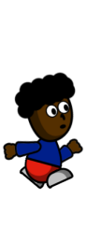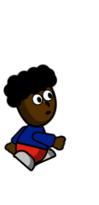

* for the bird

